Major Global Digital Policy Frameworks in Cybersecurity

Ipseeta Nanda
School of Computer Science and Engineering
IILM University, Greater Noida, UP, India
16, Knowledge Park-II, Greater Noida 201306
*ipseeta.nanda@gmail.com

Rudraksh Mehra
School of Computer Science and Engineering
IILM University, Greater Noida, UP, India
16, Knowledge Park-II, Greater Noida 201306
rudrakshmehra290@gmail.com

Abstarct
The present study offers a thorough examination of the principal digital policy frameworks that have been embraced by nations across the globe. It examines the main elements of these frameworks, such as cybersecurity protocols, privacy laws, data protection, and forms of Internet governance. The research employs a comparative methodology to underscore the commonalities, distinctions, and nascent patterns in digital policy among diverse areas. It also looks at how these frameworks might affect global digital governance and what difficulties they would present considering developing technologies and cross-border data flows.
Keywords: Internet governance, cybersecurity, data protection, policy frameworks, digital policy, and comparative analysis
Introduction
In a world that is ever increasingly digitally connected, it is now crucial to develop digital policy frameworks to manage the advantages and challenges brought about by the rapid advancement of technology. These frameworks not only ensure the protection of people's rights but also foster innovation and economic advancement by serving as a set of guidelines for policymakers and other institutions navigating the complex world of digital governance. Prominent worldwide frameworks for digital policy encompass a wide range of themes, including data privacy, cybersecurity, internet governance, and digital rights. This article aims to provide a comprehensive overview of the primary international digital policy frameworks with assistance from national governments and international organizations. Here, key components of these frameworks are examined, along with the implications they have for business, society, and technology, to better understand the evolving landscape of digital governance.
Using a comparative approach, it identifies new trends, differences, and parallels between various fields and legal systems. We'll start by defining digital policy and discussing its importance in the context of the contemporary digital ecosystem. It then looks at the main international digital policy frameworks, including those established by global organizations like the United Nations and regional groups like the European Union. We shall examine the objectives, principles, and legal requirements of each framework. Internet regulation: global digital policy following Snowden. examines global digital policies following Snowden, with a particular emphasis on governance concerns and the implications for internet regulation [1].
It will also look at the opportunities and challenges associated with implementing these frameworks, accounting for factors such as technological advancement, cross-border data flows, and geopolitical dynamics. It also assesses how well the current frameworks for digital policy address contemporary issues including data protection, cybersecurity threats, and privacy rights. This article's main objective is to increase our knowledge of the major international frameworks for digital policy and how they impact society, innovation, and digital governance. "Regulating Code: Better Regulation and Good Governance in the Information Age" It looks at governance concerns in the era of information and argues for reasonable laws and effective government [2]. In today's linked and digitalized world, the development and implementation of digital policy frameworks are now crucial to address the myriad opportunities and issues brought about by the rapid advancement of technology. By closely examining the quickly evolving field of digital policy, the future prediction modifies and develops policies that ensure a safe, secure, and inclusive digital environment for all stakeholders. These frameworks serve as a set of guidelines for nations, international organizations, and other stakeholders, providing a methodical approach to navigating the complex field of digital governance. International laws and regulations pertaining to the digital economy are guiding the path of the digital age. studies global digital policy and regulatory frameworks and plots the future direction of the internet economy [3]. Supervising the Digital and Internet Revolutions: Challenges, Mechanisms, and Effects. emphasizes the challenges and dynamics of
Important international frameworks for digital policy span a wide range of subjects, such as digital rights, cybersecurity, data privacy, internet governance, and emerging technologies. The development of digital technology has transformed practically every aspect of human life, from commerce and communication to healthcare and education. Permissionless Innovation presents the ongoing case for total technical freedom. advocates of complete technical independence and unrestricted innovation while creating foundations for digital policy. An Introduction to Information Technology Economics explores the impact of IT economics on digital policy frameworks and explains the field. It looks at the concept of Internet governance, highlighting shortcomings and voicing doubts about its effectiveness [5-8]. Although these developments have created previously unheard-of chances for creativity, economic expansion, and social betterment, they have also greatly increased privacy, security, equity, and ethical problems. As a result, authorities everywhere have realized that to properly regulate the digital sphere, strong and flexible frameworks must be created. This paper's goal is to present a thorough study of the main international digital policy frameworks that have been embraced by nations, areas, and organizations.
The worldwide conflict over Internet governance. looks at the power conflicts and implications for digital policy frameworks in the worldwide fight for internet governance [9–10].
Through an analysis of these frameworks' goals, guiding principles, and regulatory actions, it seeks to clarify how they influence digital governance and propel socio-economic growth. It will be possible to discern developing patterns, variances, and similar themes among various locations and jurisdictions by using a comparative approach. The topic of digital policy and its importance in the context of the current digital ecosystem will be explored before the conversation gets underway. In reaction to changes in societal demands, geopolitical conditions, and technology breakthroughs, digital policy frameworks have developed. The spread of digital technology, rising cybersecurity risks, and growing worries about data privacy and protection are the main forces for the creation of digital policy frameworks. Additionally, it offers a summary of the main international frameworks for digital policy, including those set up by regional organizations like the European Union and the Asia-Pacific Economic Cooperation (APEC) as well as international organizations like the World Trade Organization (WTO) and the United Nations. The goals, guiding concepts, legal frameworks, and difficulties encountered during implementation will all be examined. the interaction of new technologies like biotechnology, blockchain, Internet of Things (IoT), and artificial intelligence (AI) with digital policy frameworks. Internet governance: rules, powers, and regulations. It examines and analyses the power dynamics, rules, and governance frameworks that shape the Internet.
Cyberspace governance methods are examined in The Governance of Cyberspace, Politics, Technology, and Global Restructuring [11–12]. Technological advancements are transforming economies, cultures, and sectors, posing ethical, regulatory, and governance concerns as well as possibilities for policymakers. A consideration of the effects of significant international digital policy frameworks on different stakeholders, including corporations, governments, civil society organizations, and individual users, will also be included. This study aims to investigate the effects of these frameworks on digital rights, freedom of expression, information access, and economic possibilities, with a particular focus on marginalized people and developing nations. This study looks at the lessons that may be drawn from the privatization of the domain name system and the Internet backbone network, highlighting the significance of comprehending previous errors to guide future policy choices [13–14]. Additionally, it will evaluate how well the current frameworks for digital policy handle modern problems including algorithmic bias, disinformation, online radicalization, and cybersecurity concerns. Here, it examines case studies and best practices from various geographical areas to show effective methods of digital governance and point out areas in need of development.
methods: This section describes the methods used to examine the main international frameworks for digital policy. It includes the study's ethical considerations, data-gathering strategies, data analysis approaches, and research design. The objective is to guarantee the validity and dependability of the research findings while bringing transparency and rigor to the process.
Research Design: This study uses a comparative analysis of the main international digital policy frameworks as part of a predominantly qualitative research design. Examining records, studies, laws, and official declarations from national and regional administrations as well as international organizations will be part of the investigation. Furthermore, case studies and empirical research may be incorporated to offer valuable perspectives on the execution and consequences of digital policy frameworks within environments.
Data Collection: The process of collecting data will entail obtaining pertinent papers and materials about the main international digital policy frameworks from reliable sources, including official publications, academic journals, websites run by governments, and the repositories of international organizations. Legislative acts, policy documents, reports, white papers, regulatory guidelines, and research studies are examples of key documents.
Data Analysis: There will be multiple steps in the data analysis process, which include:
Document Review: To identify important themes, goals, guiding principles, legal requirements, and implementation issues related to significant international frameworks for digital policy, the gathered documents will be methodically examined.
Comparative Analysis: To examine the parallels, discrepancies, and new developments among various digital policy frameworks, a comparative method will be employed. Common themes, best practices, and areas for digital governance improvement will be found with the use of this investigation.
Case Studies: To offer empirical support and contextual understanding of the application and effects of digital policy frameworks in particular areas or nations, case studies will be looked at. Three criteria will be used to pick cases: representativeness, variety, and relevance.
Thematic Analysis: To find and examine recurrent themes, patterns, and problems in the data that has been gathered, thematic analysis will be done. This procedure entails data coding, code categorization into themes, and interpretation of the results regarding the study goals.
Researching digital policy frameworks requires careful attention to ethical issues, especially those about data privacy, confidentiality, and intellectual property rights.
The study method will adhere to the following ethical guidelines:
courtesy toward participants The confidentiality and care of any gathered personal data shall be maintained, and participants' right to privacy will be upheld.
Transparency: The goals, procedures, and possible ramifications of the study will all be clearly communicated to stakeholders throughout the transparent research process.
Informed Consent: In situations when primary data collection using human subjects is carried out, participants shall be informed about their rights and the goal of the study in order to receive informed consent.
Data Security: Various measures, such as encryption, password protection, and secure data storage, will be implemented to guarantee the security and integrity of data that is gathered, stored, and analyzed.
Attribution & Acknowledgment: All sources used in the study will be properly credited, and any people or groups that helped with the research will receive recognition. Following these methodological guidelines will help this research produce insightful analyses of the main international frameworks for digital policy and increase our understanding of digital governance and policy analysis.
Here are examples of a comparison table for different research methods:
Research Method | Description | Advantages | Disadvantages
Survey | Collects data from a sample population through questionnaires or interviews | Provide a large amount of quantitative data. Can be easily distributed and completed by participants | May suffer from response bias or low response rates. Limited depth of information compared to other methods.
Case Study | In-depth analysis of a single individual, group, or organization over time | Allows for detailed exploration of complex phenomena in real-life contexts. Provide rich, qualitative data | Results may not be generalized to other contexts. Time-consuming and resource-intensive
Experiment | Manipulates variables to observe cause and effect relationships under controlled conditions | Allows for establishing casual relationships between variables. Provides high internal validity. | May lack external validity if findings cannot be generalized to real world settings. Requires careful control of variables, which may limit ecological validity
Content Analysis | Analyses textual or visual data to identify patterns, themes, or trends. | Can analyse large amount of data efficiently. Provides insights into cultural, social, or linguistic phenomena | Subject to researcher bias in coding and interpretation. Relies on availability and quality of existing data.

This table provides a brief overview of each research method, along with its advantages and disadvantages. It explores the emergence of the network society, analyzing its socio-economic implications and relevance for digital policy frameworks in an increasingly interconnected world [20-21].
Researchers can use this information to select the most appropriate method based on their research questions, objectives, and resources. The typical flow of a research study follows a structured process, depicted in a block diagram, from formulating research questions to presenting findings in a research report. At the outset, researchers define the research question or hypothesis they seek to investigate. This initial stage is crucial as it shapes the direction and scope of the study. Once the research question is established, researchers proceed to select appropriate research methods tailored to address the research objectives. This stage involves careful consideration of qualitative, quantitative, or mixed-method approaches, depending on the nature of the inquiry.

Subsequently, researchers embark on data collection, gathering relevant information through surveys, interviews, observations, or archival research. The collected data is then subjected to rigorous analysis using appropriate statistical or qualitative techniques, depending on the research design and objectives. The analysis phase involves organizing, synthesizing, and interpreting the data to derive meaningful insights and identify patterns or trends. Following data analysis, researchers interpret the results within the context of existing literature and theoretical frameworks. This stage entails critically evaluating findings, discussing implications, and highlighting limitations or areas for further research. Finally, researchers communicate their findings and conclusions through a research report, which typically includes an introduction, literature review, methodology section, results, discussion, and conclusion. The research report serves as a comprehensive document that synthesizes the entire research process, providing transparency, accountability, and valuable contributions to the academic or professional community. Overall, the block diagram illustrates the sequential progression of stages in a research study, emphasizing the iterative nature of inquiry and the systematic approach to generating new knowledge. A block diagram related to different research methods, here's a simple representation:

INTERPRETATION & CONCLUSION
DATA ANALYSIS TECHNIQUES
DATA COLLECTION PROCEDURES
RESEARCH METHODS
RESEARCH QUESTION
RESEARCH REPORT

Figure:

This block diagram illustrates the typical flow of a research study, from formulating research questions to presenting the findings in a research report. Each block represents a stage in the research process, including defining the research question, selecting appropriate research methods, collecting and analyzing data, interpreting the results, and finally, communicating the findings through a research report.
Data Visualizations
To complement the comparative analysis and provide clearer insights into the global digital policy frameworks, a set of Tableau visualizations were created based on the data gathered. The visualizations illustrate various cybersecurity indices and digital development metrics across different regions. These visualizations include:
1. Heatmap:
A heatmap gives a regional comparison of cybersecurity readiness by showing the relative performance of countries across different indices. The visualization helps in identifying areas that need improvement and regions that excel in cybersecurity measures.
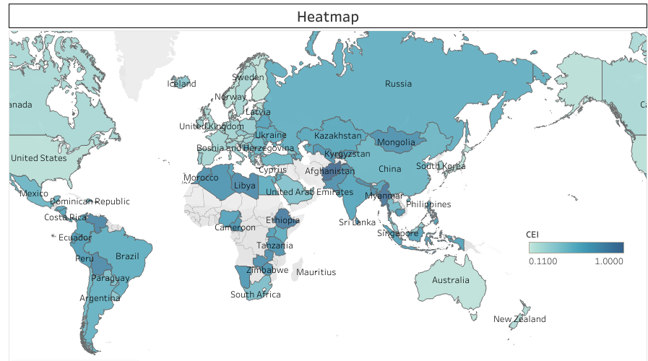
2. Scatter Plot:
The scatter plot explores the relationship between the Cybersecurity Effectiveness Index (CEI) and the Digital Development Level (DDL), illustrating correlations between these metrics across different nations. It helps in identifying patterns in cybersecurity and digital development readiness.
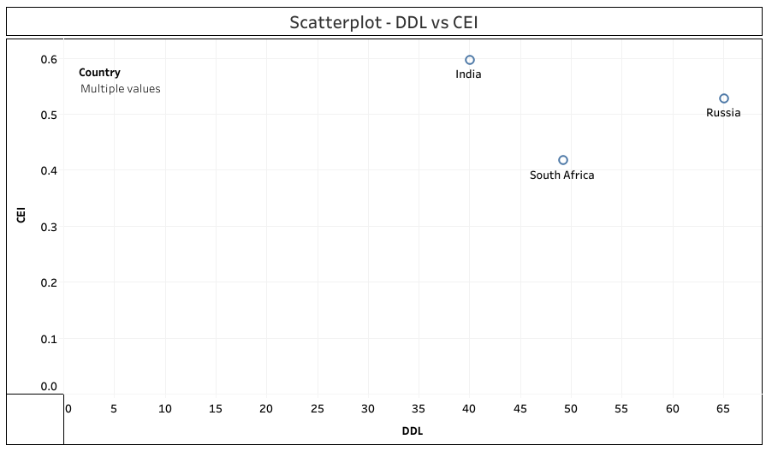
3. Bar Chart:
A bar chart compares GCI, CEI, and NSCI for selected countries, allowing for easy visual comparison of these indices. It provides an understanding of how various nations perform in cybersecurity.

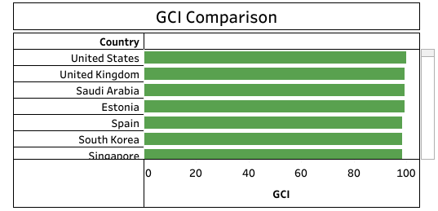
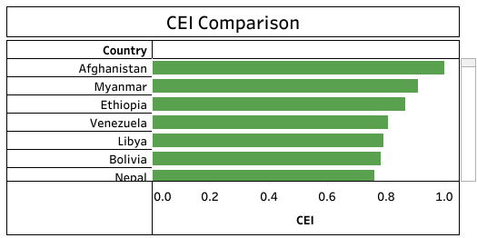
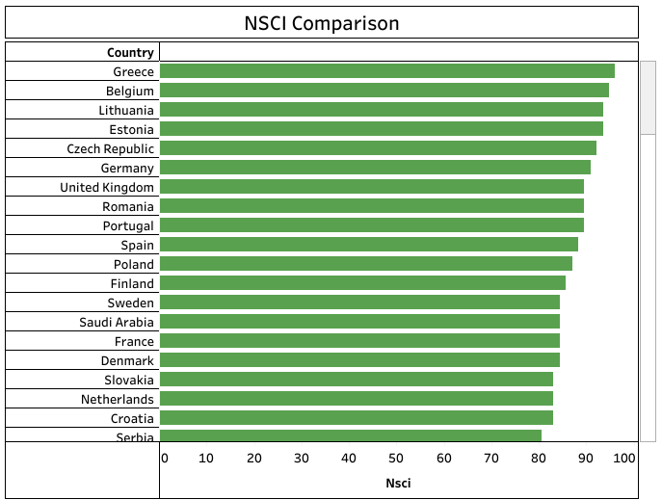

4. Tabular Representation:
A table provides a comparative view of GCI, CEI, NSCI, and DDL for each country. This tabular format allows for detailed analysis and easy referencing of the different cybersecurity and digital development metrics.
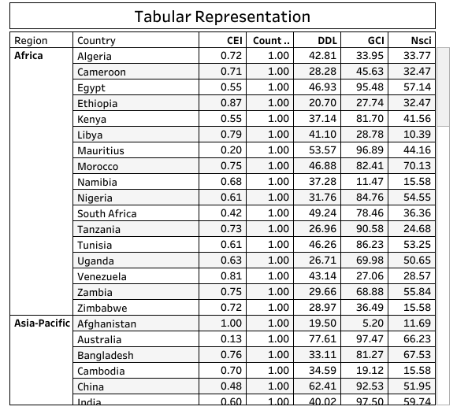

Case studies
These are detailed examinations of a particular subject, event, or phenomenon, typically conducted to analyze real-life situations, understand complex issues, or explore specific topics in depth. In academic research, case studies are often used in qualitative research methodologies to provide rich, contextualized insights into a particular problem or scenario. They involve collecting and analyzing data from various sources such as interviews, observations, documents, and archival records to construct a comprehensive understanding of the case under investigation. Case studies can be valuable in both academic and professional settings, offering researchers, practitioners, and policymakers a deeper understanding of complex issues, practical applications, and lessons learned from real-world experiences. They provide opportunities for detailed analysis, theory building, hypothesis testing, and the exploration of causal relationships within specific contexts.
A few examples of Major Global Digital Policy Frameworks:
- General Data Protection Regulation (GDPR) - Implemented by the European Union to regulate the processing of personal data and protect the privacy rights of EU citizens. The GDPR, implemented in 2018, is a comprehensive data protection law enacted by the European Union (EU). It aims to give EU citizens more control over their data and harmonize data privacy laws across EU member states. The regulation applies to all organizations that process the personal data of EU residents, regardless of where the organization is located. Key provisions include requirements for obtaining consent for data processing, the right to access and correct personal data, the right to erasure (also known as the "right to be forgotten"), data breach notification obligations, and stringent penalties for non-compliance.

- California Consumer Privacy Act (CCPA) - Enacted in the state of California, USA, to enhance privacy rights and consumer protection for residents of California. The CCPA, enacted in 2018 and became effective in 2020, is a landmark privacy law in the state of California, USA. It grants California residents greater control over their personal information held by businesses. The CCPA applies to businesses that meet certain criteria, including annual gross revenue thresholds or the collection of large amounts of consumer data. Among its provisions are requirements for transparency about data collection practices, the right to opt out of the sale of personal information, the right to access personal information, and non-discrimination rights. The CCPA also imposes penalties for non-compliance and gives consumers the right to bring private lawsuits in the event of data breaches.
- Personal Information Protection Law (PIPL) - Introduced in China to regulate the collection, use, and transfer of personal information by organizations and individuals. The PIPL is a data protection law enacted by China in 2021 to regulate the processing of personal information by organizations and individuals. It imposes obligations on entities that handle personal information, including requirements for obtaining consent, data processing limitations, data subject rights, cross-border data transfers, and data security measures. The PIPL also introduces significant penalties for violations, including fines of up to 50 million yuan (approximately USD 7.7 million) or 5% of annual revenue, whichever is higher.
- Digital Charter - Proposed by the Canadian government to outline principles for building trust and confidence in the digital world, including privacy protection, data ownership, and online safety. Digital India Programme - Launched by the Government of India to transform India into a digitally empowered society and knowledge economy through various initiatives such as digital infrastructure development, digital literacy, and e-governance services. These examples represent diverse approaches to digital policy frameworks aimed at addressing various aspects of data protection, privacy, cybersecurity, and digital rights in different regions around the world.

- Personal Data Protection Act (PDPA) - Introduced and enforced by Singapore, regulates the collection, use, and disclosure of personal data concerning residents. It defines personal data broadly, encompassing any information identifying individuals. First enacted on October 15, 2012, the PDPA was soon updated to align with the pace of the GDPR through the Personal Data Protection (Amendment) Act 2020. From 2020, amendments to the PDPA have been introduced gradually under the Personal Data Protection (Amendment) Act 2020, with key provisions taking effect on February 1, 2021. The PDPA doesn't apply to business contact information or anonymized data. Amendments introduced criminal offenses, mandatory breach notifications, and expanded consent exceptions, effective February 2021. The maximum fine took effect in October 2022. The PDPA recently underwent a comprehensive review, resulting in the Personal Data Protection (Amendment) Act 2020. It outlines obligations regarding data protection provisions and Singapore's Do Not Call (DNC) Registry. Other regulations include the Personal Data Protection Regulations 2021, addressing data transfers, access requests, and disclosure rights. The PDPC offers advisory guidelines for interpretation. The PDPA ensures businesses comply with stringent data protection standards, reflecting Singapore's commitment to safeguarding personal information.

- The Privacy Act 1988 (Privacy Act) - Australia's primary legislation governing the protection of personal information across both the federal public and private sectors. Enacted to regulate the collection, use, storage, and disclosure of personal data, it underwent significant amendments in 2014 and 2017 to bolster privacy safeguards. The Privacy Act Review, initiated in 2020 following recommendations from the Australian Competition and Consumer Commission, aimed to enhance privacy protection further. Notably, urgent reforms in December 2022 bolstered penalties and enforcement powers in response to data breaches. Key features of the Privacy Act include the Notifiable Data Breaches scheme, requiring entities to notify affected individuals and the Office of the Australian Information Commissioner (OAIC) of data breaches posing risks of serious harm. The OAIC oversees compliance, investigates breaches, and administers enforcement measures, including civil penalties and privacy assessments. The Privacy Act is supplemented by the Privacy Regulation 2013 and the Privacy (Credit Reporting) Code 2014. Following the Privacy Act Review, released in February 2023, the government's response in September 2023 aims to refine privacy settings, empower consumers, and align privacy laws with evolving digital landscapes.

- The Brazilian General Data Protection Law (LGPD) - Enacted as Federal Law no. 13,709/2018, officially came into effect on September 18, 2020, marking Brazil's inaugural comprehensive legislation in data protection. Modelled after the principles of the EU General Data Protection Regulation (GDPR), the LGPD aims to safeguard fundamental rights in the digital sphere. Despite its inception in 2020, the LGPD's penal provisions were only enforceable starting August 1, 2021, allowing entities a grace period for compliance adjustments. This legislation applies universally, transcending geographical boundaries, and is binding on any entity engaged in data processing activities within Brazilian territory or handling data collected from Brazil. Exceptions exist, including private or non-economic processing, journalistic, artistic, or academic pursuits, as well as specific public interests. This legislation represents a significant stride in Brazil's data protection journey, aligning the country's legal framework with global standards and acknowledging the criticality of privacy rights in the digital era. The LGPD's inception underscores Brazil's commitment to fostering a secure and transparent environment for personal data processing, thereby fortifying trust between individuals and entities engaging in data-driven activities.

- Digital Personal Data Protection Act (DPDP) - passed by the Indian Parliament in August 2023, emerged as India's inaugural legislation addressing the processing of digital personal data. This Act signifies a crucial step towards recognizing both individuals' rights to safeguard their personal data and the necessity of processing such data for lawful purposes. It imposes obligations on Data Fiduciaries, outlines rights and duties of Data Principals, and introduces financial penalties for breaches. India's journey towards comprehensive data protection legislation began with the Supreme Court's recognition of the right to privacy in 2017. Following several unsuccessful attempts, including the withdrawal of the Data Protection Bill 2021, the Digital Personal Data Protection Bill 2022 finally gained traction. The DPDP Act applies to digital personal data processed within India, online or offline but digitized, and extends its jurisdiction to entities processing data related to Indian data principals, regardless of their location. With the DPDP Act now in effect, India seeks to enhance data protection and accountability for entities handling citizens' data, aligning itself with global standards exemplified by models like the EU's GDPR. The establishment of the Data Protection Board of India underscores the Act's significance, emphasizing the nation's commitment to safeguarding personal data in the digital age
Case studies represent a versatile research method employed across various disciplines, offering a detailed examination of specific cases or phenomena within their natural contexts. They come in several forms, each with distinct objectives and approaches: descriptive, exploratory, instrumental, and critical case studies. Through their holistic nature, case studies provide researchers with valuable insights into complex phenomena that may not be attainable through other methods. Descriptive case studies serve as a foundational approach to understanding a particular case or phenomenon in detail. These studies provide comprehensive descriptions without necessarily testing explicit hypotheses or employing a theoretical framework. Instead, they focus on presenting a thorough account of the case, often through qualitative data collection methods such as interviews, observations, and document analysis. By offering rich descriptions, descriptive case studies contribute to the initial understanding of a topic, laying the groundwork for further investigation. In contrast, exploratory case studies aim to delve into new or emerging topics to generate hypotheses or theories for future research. These studies seek to explore why a particular phenomenon occurs by identifying and analysing causal relationships and underlying mechanisms. Through in-depth exploration and analysis, researchers can uncover patterns, trends, and potential explanations, thus contributing to the development of theoretical frameworks. Exploratory case studies often employ qualitative methods but may also incorporate quantitative data to support their findings and hypotheses. Instrumental case studies focus on using a specific case to shed light on broader issues or theories. Rather than examining the case itself in isolation, instrumental case studies leverage it to gain insights into larger phenomena or theoretical concepts. Researchers select cases strategically, aiming to illuminate aspects of theory or practice that may not be easily observable through other methods. Instrumental case studies facilitate the application of theoretical concepts to real-world situations, bridging the gap between theory and practice through empirical investigation. Critical case studies take a more challenging approach by examining extreme or unusual cases to challenge existing theories or assumptions. These studies aim to uncover contradictions, anomalies, or limitations within established frameworks by scrutinizing cases that deviate from the norm. By interrogating assumptions and exploring alternative perspectives, critical case studies contribute to theoretical refinement and paradigmatic shifts. Through rigorous analysis and critique, researchers can deepen their understanding of complex phenomena and stimulate debate within their respective fields. Overall, case studies offer a holistic research approach that allows researchers to explore complex phenomena within their natural contexts. By immersing themselves in specific cases, researchers can gain deep insights into the intricacies of human behavior, organizational dynamics, social processes, and other phenomena that may not be fully captured through quantitative methods alone. Case studies enable researchers to examine real-world situations in depth, considering multiple perspectives and contextual factors that influence outcomes. Moreover, case studies facilitate the integration of theory and practice by providing empirical evidence to support theoretical concepts or by challenging existing frameworks. Through careful analysis and interpretation, researchers can elucidate the underlying mechanisms driving observed phenomena, contributing to the advancement of knowledge within their respective disciplines. The case studies represent a valuable research method that offers unique advantages for investigating complex phenomena. Whether descriptive, exploratory, instrumental, or critical, case studies provide researchers with a means to develop deeply into specific cases within their natural contexts, generating insights that may not be attainable through other methods. By employing diverse approaches and methodologies, case studies contribute to theoretical development, empirical understanding, and the advancement of knowledge across various fields of study.
Merits and Demerits:
Merits of Major Global Digital Policy Frameworks related to Cyber Security, Forensics & National Security:
- Enhanced Coordination: Global digital policy frameworks facilitate collaboration and information sharing among nations, organizations, and stakeholders, thereby improving coordination in addressing cyber threats and enhancing overall security.
- Standardization: These frameworks promote the adoption of common standards, best practices, and protocols for cyber security measures and digital forensics procedures, leading to greater consistency and interoperability in response efforts.
- Capacity Building: By providing guidelines and resources, digital policy frameworks support capacity-building initiatives in cyber security and forensics, empowering nations to develop robust capabilities to detect, prevent, and respond to cyber threats.
- Legal Clarity: Clear and comprehensive policy frameworks help establish legal frameworks for cyber security and digital forensics, providing clarity on jurisdictional issues, law enforcement procedures, and rights of individuals, thereby reducing ambiguity and improving accountability.
- International Cooperation: Major global digital policy frameworks foster international cooperation and collaboration in combating cybercrime and addressing transnational security challenges, promoting trust, and facilitating mutual assistance among nations.
Demerits of Major Global Digital Policy Frameworks related to Cyber Security, Forensics & National Security:
- Compliance Challenges: Implementing global digital policy frameworks may pose challenges for nations due to differences in legal systems, cultural norms, and resource constraints, leading to difficulties in achieving full compliance and enforcement.
- Sovereignty Concerns: Some nations may perceive global digital policy frameworks as encroachments on their sovereignty and national interests, leading to resistance or reluctance to adopt or comply with international standards and regulations.
- Enforcement Gaps: Despite the existence of global digital policy frameworks, enforcement mechanisms may be weak or inadequate, leading to challenges in holding perpetrators accountable for cybercrimes and breaches of national security.
- Privacy Risks: Overly stringent digital policy frameworks may pose risks to privacy and civil liberties, leading to concerns about government surveillance, data collection practices, and potential abuse of power in the name of national security.
- Adaptability Issues: Rapid technological advancements and evolving cyber threats may outpace the capabilities of existing digital policy frameworks, necessitating frequent updates and revisions to ensure their relevance and effectiveness.

Overall, while major global digital policy frameworks offer significant benefits in enhancing cyber security, forensics, and national security, they also face challenges related to compliance, sovereignty, enforcement, privacy, and adaptability. Addressing these challenges requires ongoing dialogue, collaboration, and innovation among nations, organizations, and stakeholders to develop agile and resilient frameworks that effectively address emerging digital threats while upholding fundamental rights and values.

Results and Discussion
The analysis of major global digital policy frameworks related to cybersecurity, forensics, and national security reveals several critical insights that inform our understanding of the current landscape and future directions. The case studies and accompanying visualizations from the Tableau project offer a comprehensive view of how various countries approach the challenges of cybersecurity.

5.1 Key Findings
- Diversity in Approaches: The case studies illustrate that different countries adopt varied strategies based on their unique socio-political contexts, resource availability, and threat perceptions. For instance, Estonia's proactive digital identity initiatives contrast sharply with India's ongoing struggles with capacity building and regulatory harmonization. This diversity underscores the importance of contextualized frameworks that consider local conditions while aligning with global standards.
- Impact of Frameworks: The adoption of global digital policy frameworks has generally led to enhanced coordination and cooperation among nations, fostering a more cohesive approach to tackling cyber threats. Countries like the United States and those in the European Union have shown improved resilience due to their adherence to established standards and protocols. However, the effectiveness of these frameworks varies significantly, as demonstrated by the challenges faced by nations in compliance and implementation.
- Compliance Challenges: Many countries encounter significant hurdles in complying with international frameworks due to differing legal systems, cultural norms, and levels of economic development. This disparity can create gaps in enforcement, leading to a fragmented cybersecurity landscape. As evidenced in the Indian case study, while policies exist, their effectiveness can be hampered by inadequate resources and insufficient training, highlighting the need for targeted capacity-building initiatives.
- Privacy and Civil Liberties Concerns: The findings also suggest that while global digital policy frameworks enhance national security, they must be balanced with the protection of individual rights. Overly stringent policies may infringe on privacy and civil liberties, raising concerns about government surveillance and data collection practices. This aspect requires careful consideration in the formulation and implementation of future frameworks.
- Need for Adaptability: Rapid technological advancements and evolving cyber threats necessitate continuous updates and revisions to existing digital policy frameworks. As illustrated in the case studies, frameworks that fail to adapt quickly may become obsolete, leaving nations vulnerable to emerging threats. This calls for dynamic policies that can evolve alongside technology and the cyber threat landscape.

Implications for Policy Development
The insights gained from this research have significant implications for policymakers seeking to enhance national cybersecurity capabilities:
- Integrated Policy Responses: Policymakers should prioritize integrated responses that encompass cybersecurity, digital forensics, and national security, ensuring that frameworks address the interconnected nature of these domains.
- International Collaboration: Enhanced international cooperation and information sharing are crucial for addressing transnational cyber threats. Frameworks should facilitate collaboration between countries, organizations, and stakeholders to improve collective security.
- Focus on Capacity Building: Investments in capacity building, education, and training are essential for enabling nations to effectively implement cybersecurity frameworks. This includes fostering a skilled workforce capable of adapting to evolving threats and technologies.

Conclusion and Future Scope:
In conclusion, the examination of major global digital policy frameworks related to cyber security, forensics, and national security reveals several important insights. Firstly, it is evident that digital technologies have significantly transformed the landscape of security threats, necessitating the development of comprehensive policy frameworks to address emerging challenges. The analysis highlights the diversity of approaches adopted by different countries and international organizations in formulating digital policies, reflecting varying priorities, capabilities, and threat perceptions. Furthermore, the study underscores the interconnected nature of cyber security, forensics, and national security, emphasizing the need for integrated and collaborative policy responses. Effective digital policy frameworks should not only focus on mitigating cyber threats but also incorporate mechanisms for cybercrime investigation, attribution, and response to enhance national security. Moreover, the importance of balancing security objectives with considerations of privacy, civil liberties, and international cooperation is evident in the design and implementation of these frameworks. Additionally, the examination of global digital policy frameworks reveals ongoing challenges and areas for improvement. These include the need for harmonization of legal frameworks across jurisdictions, enhancement of international cooperation mechanisms, capacity-building efforts, and investment in research and development to address evolving threats. Furthermore, the study highlights the importance of regular evaluation and adaptation of digital policy frameworks in response to technological advancements and emerging security risks.
In conclusion, while significant progress has been made in developing digital policy frameworks related to cyber security, forensics, and national security, continued efforts are essential to ensure their effectiveness, relevance, and adaptability in an increasingly complex and interconnected digital environment. By fostering collaboration, innovation, and responsible governance, policymakers can strengthen the resilience of digital infrastructure and safeguard national security interests in the digital age.
The future scope of Major Global Digital Policy Frameworks related to Cyber Security, Forensics & National Security is promising and encompasses several key areas:
Emerging Technologies Integration: As technologies such as artificial intelligence, blockchain, and quantum computing continue to advance, future digital policy frameworks will need to incorporate provisions for their responsible development, deployment, and regulation. This includes addressing potential security risks, ethical considerations, and governance mechanisms to ensure their safe and secure utilization.
Cross-Sector Collaboration: The scope of digital policy frameworks will expand to encompass broader sectors beyond traditional cyber security and national security domains. Collaborative efforts between governments, private sector entities, academia, and civil society will be crucial to addressing multidimensional cyber threats affecting critical infrastructure, healthcare systems, financial institutions, and supply chains.
International Norms and Standards: Future digital policy frameworks will focus on the development of international norms, standards, and guidelines to promote responsible behavior in cyberspace and prevent malicious activities. This includes efforts to establish rules of engagement, norms of state behaviour, and confidence-building measures to enhance global cyber stability and resilience.
Cyber Resilience and Incident Response: With the increasing frequency and sophistication of cyber-attacks, future policy frameworks will emphasize the importance of cyber resilience and incident response capabilities. This includes investing in proactive measures such as threat intelligence sharing, cyber hygiene awareness, and cyber training programs to enhance organizational and national resilience against cyber threats.
Data Protection and Privacy: The future scope of digital policy frameworks will include robust provisions for data protection, privacy, and individual rights in cyberspace. This will involve strengthening regulations such as the General Data Protection Regulation (GDPR) and developing mechanisms for cross-border data flows while balancing security and privacy considerations.
Capacity Building and Awareness: Future policy frameworks will prioritize capacity-building initiatives and awareness-raising campaigns to enhance cyber security and digital forensics capabilities at the national and international levels. This includes investing in education, training, and skills development programs to address the growing demand for cyber security professionals and forensic experts.
Ethical and Legal Considerations: As technological advancements raise ethical and legal challenges, future digital policy frameworks will need to address issues such as algorithmic bias, digital rights, and accountability in the use of digital technologies. This includes establishing ethical guidelines, oversight mechanisms, and regulatory frameworks to ensure responsible and transparent use of emerging technologies. In summary, the future scope of Major Global Digital Policy Frameworks related to Cyber Security, Forensics & National Security will encompass a wide range of areas, including emerging technologies integration, cross-sector collaboration, international norms and standards, cyber resilience, data protection and privacy, capacity building, awareness, and ethical and legal considerations. Addressing these challenges will require sustained efforts and collaboration among governments, private sector entities, academia, and civil society to ensure a safe, secure, and resilient digital future.
References:
- Mueller, M. L. (2017). Governing the internet: global digital policy in the post-Snowden era. Global Policy, 8(4), 538-544.
- Brown, I., & Marsden, C. T. (2013). Regulating Code: Good Governance and Better Regulation in the Information Age. MIT Press.
- Kurbalija, J., & Gelvanovska, N. (2017). Mapping the digital future: Global policy and regulation for the internet economy. DiploFoundation.
- Helberger, N., & Dufft, N. (Eds.). (2021). Governing the Internet and Digital Transformations: Challenges, Dynamics, and Implications. Springer.
- Thierer, A. D. (2015). Permissionless innovation: The continuing case for comprehensive technological freedom. Mercatus Center at George Mason University.
- Varian, H. R., Farrell, J., & Shapiro, C. (2004). The Economics of Information Technology: An Introduction. Cambridge University Press.
- van Eeten, M. J., & Mueller, M. L. (2013). Where is the governance in internet governance? New Media & Society, 15(5), 720-736.
- Zittrain, J. (2008). The Future of the Internet--And How to Stop It. Yale University Press
- DeNardis, L. (2014). The Global War for Internet Governance. Yale University Press.
- Brousseau, E., Marzouki, M., & Méadel, C. (Eds.). (2011). Governance, Regulations, and Powers on the Internet. Cambridge University Press.
- Froomkin, A. M. (Ed.). (2003). The Governance of Cyberspace: Politics, Technology and Global Restructuring. Routledge.
- Kesan, J. P., & Shah, R. C. (2006). Fool Us Once Shame on You, Fool Us Twice Shame on Us: What We Can Learn from the Privatizations of the Internet Backbone Network and the Domain Name System. Berkeley Technology Law Journal, 21, 1367
- Mueller, M. L. (2010). Networks and states: The global politics of Internet governance. MIT Press.
- DeNardis, L. (2012). Hidden levers of Internet control: An infrastructure-based theory of Internet governance. Information, Communication & Society, 15(5), 720-736.
- Lessig, L. (1999). Code and Other Laws of Cyberspace. Basic Books.
- Froomkin, A. M. (2003). Habermas@ discourse. Stanford Law Review, 52, 401.
- MacKinnon, R. (2012). Consent of the Networked: The Worldwide Struggle For Internet Freedom. Basic Books.
- Sunstein, C. R. (2006). Infotopia: How Many Minds Produce Knowledge. Oxford University Press.
- Kallinikos, J., Aaltonen, A., & Marton, A. (2010). The ambivalent ontology of digital artifacts. MIS Quarterly, 35(2), 357-370.
- van Dijk, J. (2012). The network society. Sage.

